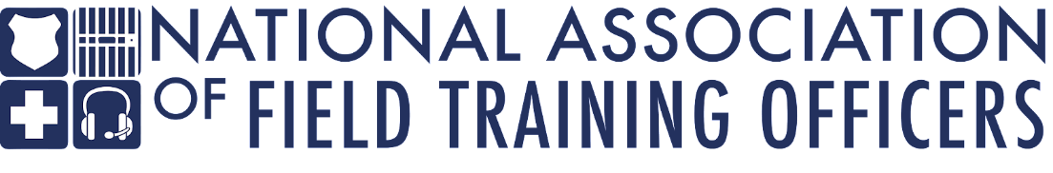

Executive Board vice president

overview
The National Association of Field Training Officers (NAFTO) is seeking a highly qualified, results-oriented, professional to serve as the Executive Board Vice President for this non-profit organization. NAFTO provides training to law enforcement agencies, including basic field training instructor, manager, and leadership courses. The Vice President provides leadership to the board, supports the president in their efforts, and guides other personnel within the NAFTO organization. The vice president facilitates communications with operations staff. The ideal candidate will be forward-thinking, organized, and not only demonstrate an understanding of the organization’s mission, but enhance the vision for the future of NAFTO.

The Vice President assists in managing partnerships with operations personnel, public safety agencies, and national organizations. They understand and promote the importance of sound decision-making and critical thinking, working independently and completing tasks in a timely manner. The Vice President demonstrates integrity and innovation in performing tasks and presents a positive public image, maintaining effective working relationships.

This position is an elected position by the NAFTO membership and works in conjunction with the other Executive Board members, but also the Executive Director (ED). The Vice President must be a current member, in good standing. This is a three-year service term and carries no restriction on reelection.

duties and responsibilities

Administrative Duties:
- Attend executive board meetings
- Assist in the preparation of board meetings if requested
- Follow statutory and regulatory annual report deadlines and responsibilities
- Takes the lead on the executive director’s annual performance evaluation
- Develops the annual report for membership distribution

Organizational Functions:
- Assume the presidency if the president is unable to fulfill their duties
- Acts as liaison to association partners where needed
- Serves as the nonprofit’s spokesperson as needed
- Fundraising
- Recommend members for committees and committee chairs
- Arranges for or takes part in new board member orientation
- Instructor liaison and development
- Responds to questions, complaints, inquiries pertaining to the policies and procedures and actions taken; resolves complaints and sensitive issues, interacts with customers
- Assists with hiring and supervising the Executive Director
- Supervise all business affairs of the Executive Board
- Creating committees and appointing committee chairs
- Provides leadership to board’s officers
- Provides leadership to association members
*This is not an exhaustive list of responsibilities and could be adjusted based on directives from the NAFTO Executive Board.

Desired skills and abilities

- Demonstrate integrity, innovation, and respect in performing assigned tasks
- Communicate complicated or technical concepts effectively, both verbally and in writing, to internal and external parties
- Perform a wide variety of responsibilities with accuracy and speed under the pressure of time-sensitive deadlines; maintain a professional demeanor during stressful situations
- Present a positive public image and maintain effective working relationships
- Make sound and reasonable decisions in accordance with laws, by-laws, and established procedure
- Excellent interpersonal, written, and verbal communication skills
- Demonstrate presentation, interpersonal, and effective communication skills
- Basic level proficiency in computer software, including MS Office (Word, PowerPoint, and Excel), Google Documents, and Adobe

Desired experience and education

- Current or previous experience in public safety, to include law enforcement, corrections, emergency medicine, or firefighting
- Must be a current member in good standing with NAFTO
- Previous experience in an administrative role and/or leadership capacity
- Experience in a fast-paced environment with a high degree of independence

