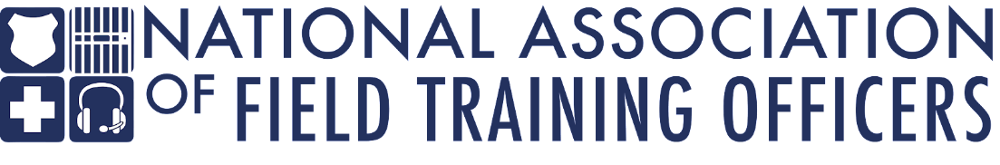

Executive Board Secretary

overview
The National Association of Field Training Officers (NAFTO) is seeking a highly qualified, detail-oriented, professional to serve as the Executive Board Secretary for this non-profit organization. NAFTO provides training to law enforcement agencies, including basic field training instructor, manager, and leadership courses. The secretary will facilitate smooth and efficient operations within the organization by providing administrative assistance, managing information, and handling communication.

The ideal candidate will be organized and demonstrate an ability to utilize technology to create and manage NAFTO documents in relation to board and organization activities.

This Executive Board Secretary is an elected position by the NAFTO membership and works in conjunction with the other Executive Board members. The Secretary must be a current member, in good standing. This is a three-year service term and carries no restriction on reelection.

duties and responsibilities

Administrative Duties:
- Attend monthly board meetings
- Maintain meeting minutes
- Provide adequate notice of upcoming meetings to NAFTO members
- Maintain previous and current association records
- Manage supplies, software, and subscriptions

Organizational Functions:

- Maintain and update Google platform
- Oversee membership lists and provide information to the board or external partners if requested
- Fundraising
- Provide monthly report to Executive Board on previous business or minute updates
- Present information at monthly Executive Board meetings upon ED request
*This is not an exhaustive list of responsibilities and could be adjusted based on directives from the NAFTO Executive Board.

Required skills and abilities

- Excellent interpersonal, written, and verbal communication skills
- Demonstrate presentation, interpersonal, and effective communication skills
- Basic level proficiency in computer software, including MS Office (Word, PowerPoint, and Excel), Google Documents, and Adobe
- Demonstrate integrity, innovation and respect in performing assigned tasks
- Communicate complicated or technical concepts effectively, both verbally and in writing, to internal and external parties
- Perform a wide variety of responsibilities with accuracy and speed under the pressure of time-sensitive deadlines; maintain a professional demeanor during stressful situations
- Detail-oriented
- Strong organizational skills

experience and education

- Current or previous experience in public safety, to include law enforcement, corrections, emergency medicine, or firefighting
- Must be a current member in good standing with NAFTO
- Previous experience in an administrative role and/or leadership capacity
- Experience in a fast-paced environment with a high degree of independence

