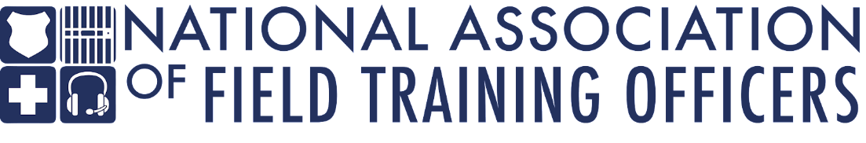

Sergeant at arms

overview
The National Association of Field Training Officers (NAFTO) is seeking a highly qualified, detail-oriented, professional to serve as the Executive Board Sergeant at Arms for this non-profit organization. NAFTO provides training to law enforcement agencies, including basic field training instructor, manager, and leadership courses. The Sergeant at Arms will facilitate smooth and efficient operations within the organization by providing administrative assistance, managing information, and handling communication.

The ideal candidate will be organized and demonstrate an ability to utilize technology to create and manage NAFTO documents in relation to board fundraising, sponsorships, and policy and procedures.

This Executive Board Sergeant at Arms is an elected position by the NAFTO membership and works in conjunction with the other Executive Board members. The Sergeant at Arms must be a current member, in good standing. This is a three-year service term and carries no restriction on reelection.

duties and responsibilities

Administrative Duties:
- Attend monthly board meetings.
- Maintain rules, regulations, and policies during meetings.
- Manage fundraising events and opportunities related to sponsorships.
- Maintain job descriptions and update when necessary.
- Maintain board book and provide revisions yearly.

Organizational Functions:

- Manage fundraising events.
- Provide monthly report to Executive Board on fundraising and sponsorships.
- Present information at monthly Executive Board meetings upon ED request.
- Manage sponsorships and other partnerships with outside organizations and businesses.
*This is not an exhaustive list of responsibilities and could be adjusted based on directives from the NAFTO Executive Board.

Required skills and abilities

- Excellent interpersonal, written, and verbal communication skills.
- Demonstrate presentation, interpersonal, and effective communication skills.
- Basic level proficiency in computer software, including MS Office (Word, PowerPoint, and Excel), Google Documents, and Adobe.
- Demonstrate integrity, innovation and respect in performing assigned tasks.
- Communicate complicated or technical concepts effectively, both verbally and in writing, to internal and external parties.
- Perform a wide variety of responsibilities with accuracy and speed under the pressure of time-sensitive deadlines; maintain a professional demeanor during stressful situations.
- Detail-oriented and strong organizational skills .

experience and education

- Current or previous experience in public safety, to include law enforcement, corrections, emergency medicine, or firefighting.
- Must be an active member of NAFTO.
- Previous experience in an administrative role and/or leadership capacity.
- Experience in a fast-paced environment with a high degree of independence.
- Present a positive public image and maintain effective working relationships.

